Sangala Mosaic User Guide
Sangala Mosaic is the Mosaic Design Tool: it turns a photograph into a LEGO-tile mosaic plan — the tiles laid out square by square on a grid, in the colors of the Tile Palette, with a parts list counting how many of each the design uses. This guide is a reference to the tools: what each control does and where it lives.
Everything runs in the browser. There is no install, no internet, and no machine to connect to.

1. The screen
Sangala Mosaic has four regions, like a workbench:
- Menu bar (top) — Open a photo or a saved project, Save your work, Print the mosaic, Settings (the gear — opens Setup: the grid and the baseplate), and ways of looking at it: Transparent and About.
- Tools (left edge) — Select picks things up; Paint, Pick, and Erase edit cells by hand after building; Tiles and Wand select tiles for grouping into masses (Section 10).
- The workspace (center) — your working surface. Your photo (or photos) and the grid frame sit here; this is where you arrange what will become the mosaic.
- Build panel (right) — the green Build It! button and everything that shapes the result: the Adjust Mosaic controls, your masses, and the Palette. The grid and the baseplate live in Setup, behind Settings.
You never connect to anything — open a photo and you can start.

2. The Tile Palette
The mosaic is built from the colors in the Tile Palette; the parts list counts how many of each the design uses.
- The palette drives the mosaic. Down the right side is the Palette — real LEGO tile colors, including several grays from very light to dark, so a mostly-gray subject still shows its shading. The mosaic uses only these colors. To change them, press Tile Colors and then Edit: click a color to turn it off or back on. Clear empties the palette so you can add just the colors you want; Reset brings back the standard set.
- Add colors from a photo. Add Tile Colors in a Photo (under Tile Colors) reads the LEGO colors out of a photo in the workspace — loose tiles, a tray of them, or a mosaic already built — and adds them to the palette as Custom Tiles, kept beside the Standard Tiles.
- The parts list counts the tiles. After you build, the status line totals them, and Save → Tile List writes every color with its count — “47 dark gray, 23 white, 8 red…” — the list to order from or build against. The printed sheet carries the same counts beneath the picture.

3. Open a photo (and build a scene)
- Click Open (or drag a picture onto the workspace). Sangala accepts .png and .jpg.
- The photo drops onto the workspace at a comfortable size. Drag its body to move it; drag a corner handle to resize it (the shape is kept, so it never stretches). Press Delete to remove a selected photo.
- Open again to add another picture. Each Open adds a layer, so you can build a scene — a background behind, a subject in front — and turn the whole composite into one mosaic.
Layer order (which picture is in front). Select a picture to open its panel on the right, then use the layer controls there to send it forward or back, so the foreground animal sits on top of the background.

4. Remove the background
Remove Background clears the backdrop from a picture so that only the subject becomes tiles:
- Select the picture.
- In its panel, turn on Remove Background. Sangala clears the backdrop from the edges inward and leaves the subject — keeping interior whites (a crane's white belly stays; only the true background goes).
- The original is never lost. Turn Remove Background off to bring the backdrop back.
With the background removed, the empty area around the subject becomes empty cells in the mosaic (or bare baseplate), not tiles.

5. The grid — framing the mosaic
The grid frame is the box on the workspace that decides what becomes the mosaic and how fine it is. Whatever falls inside the frame is what gets built.
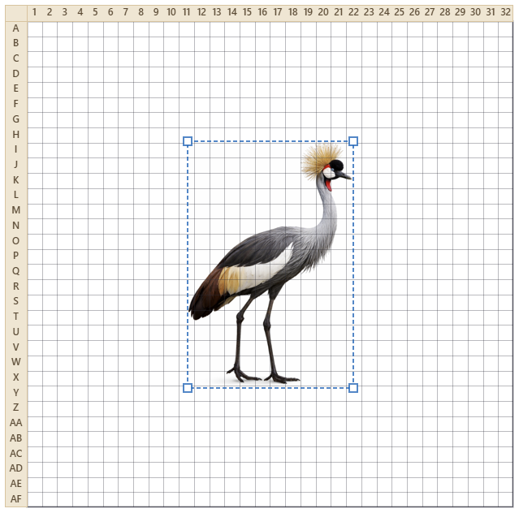
Figure 1. A photo positioned under the grid — whatever falls inside the frame becomes the mosaic.
- Move it — drag the frame's border. Resize it — drag a corner (the cells stay square).
- Fit to Photo — one press lays the grid over the photo for you: the largest area of the grid’s shape that fits the picture. Adjust from there if you want a different framing.
- Across and Down — in the Grid Controls section of Setup (press Settings), set how many tiles wide and tall. The standard baseplate is 32 × 32, and that is the default. The readout shows the real size — 32 × 32 tiles is about 256 mm ≈ 10 inches — so you know how big the finished piece will be.
- Show — three checkboxes for what you see on the workspace: Grid (the cell lines and the row and column labels — numbers across the top, letters down the side — that you follow while building), Baseplate (the studded plate behind the tiles), and Box (the outline around the mosaic). Turn any of them off — turn all three off to see just the mosaic itself.
Fewer tiles across make bigger, blockier tiles and a coarser picture; more make a finer picture that needs more, smaller tiles.

6. Build It!
Press the green Build It! button and Sangala maps the framed picture to your palette colors, cell by cell, and shows the result on its baseplate. Transparent lets you check it against the photo.
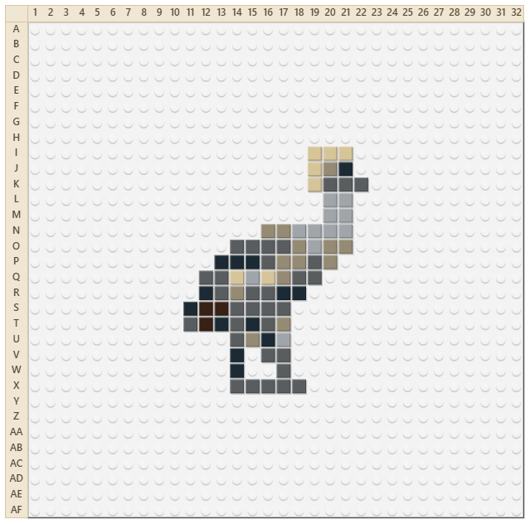
Figure 2. The finished mosaic on its baseplate.
A few controls (in the Adjust Mosaic part of the panel) shape the result; change any one and the mosaic re-maps at once:
- Ignore background (on by default) — treats the removed or empty background as empty cells, so thin parts like legs survive instead of being outvoted by a sea of sky.
- Colors — how many different tile colors to reduce the picture to. A low number gives a bolder, simpler mosaic; a high number gives more shading. Sangala always snaps these to the nearest palette colors.
- Clean up — gently fills single-tile holes and drops lone stray tiles, so the mosaic reads cleanly without erasing real detail.
- Contrast and Brightness — adjust the picture before it is mapped to tile colors.
Cells can also be edited one at a time with the hand tools (Section 9).

7. The baseplate
The built mosaic sits on a baseplate — the studded plate the tiles snap onto — so you see it the way it will really look.
- Baseplate color — choose from the Baseplate swatches in Setup (press Settings). These are limited to the colors LEGO actually sells baseplates in (White, Green, Gray, Blue, Sand, Black, Red, and Light Blue). White is the default.
- Show or hide — the Baseplate checkbox hides the plate for a clean, chart-like view of just the tiles (handy for reading the pattern). With the plate shown, the studs mark the grid; hide it and the cell lines return so empty cells stay clear.

8. Seeing the mosaic
The mosaic sits in the grid, so it is always on screen. Two ways to compare it with the photo:
- Side by side — the workspace stays live, so Open a copy of the photo and drag it beside the mosaic; adding or moving it never disturbs the mosaic.
- Transparent — make the tiles translucent so the photo shows through underneath. It stays available while painting (Section 9).
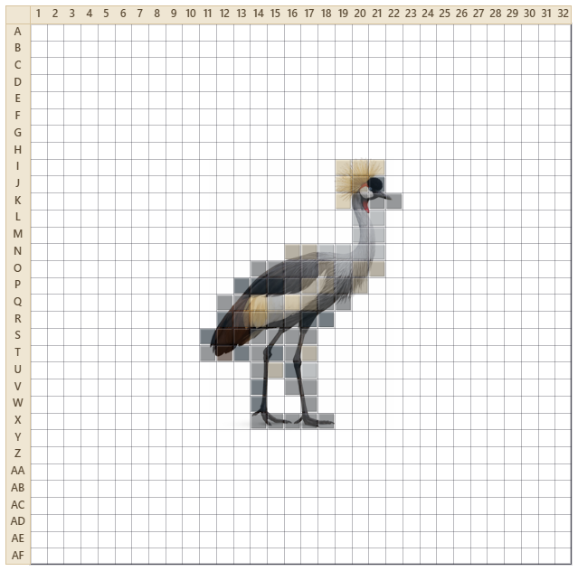
Figure 3. Transparent makes the tiles translucent so the photo shows through.

9. Editing tiles by hand: Paint, Pick, Erase
After a build, three tools on the left rail edit individual cells:
- Paint — click a color in the palette, then click or drag across cells to set them to that color. Right-click a cell to clear it.
- Pick — click a cell to grab its color, then keep painting with it.
- Erase — click or drag to clear cells back to empty (the baseplate shows through).
Undo is there. Ctrl-Z undoes your last stroke — a whole dragged line comes back in one press — and Ctrl-Y (or Ctrl-Shift-Z) redoes it. Rebuilding, or changing the photo, resets hand edits.

10. Masses — named groups of tiles
A mass is a named group of tiles — a head, a leg, any region — that can be reselected and adjusted as one thing. After a build, select tiles and Group them:
- Tiles — drag a box to select the tiles inside it, whatever color they are.
- Wand — click a tile to select the whole connected run of that color.
- Shift-click adds or drops a single tile; Alt removes; Ctrl-D deselects. The three selection tools all feed one selection, so mix them freely.
- Group turns the selection into a named mass. Select (the arrow) reselects a mass with one click; change its tiles and the button reads Update Mass — press it to keep the change.
Masses are saved in the project and keep their names when it is reopened.

11. The parts list (bill of materials)
After Build It!, the status line gives the headline — how many tiles in how many colors. Save → Tile List writes the full list as a text file: every color with its count, sorted most-used first, and the grand total. Print puts the same counts beneath the picture on the printed sheet (Section 12). Because Sangala builds only from the palette, every line is a color in it.

12. Saving and printing
Work leaves the tool three ways: as a saved project, as an image or tile list, or as a printed sheet.
- Save your work — the Save button gives a choice. Project saves everything as a .mosaic file — your photos, the grid, your palette, your masses, and the built mosaic — so you can reopen it later and keep editing, and you choose where it goes. Image saves a picture of the mosaic as a .png or .jpg.Tile List saves the tile counts by color as a .txt — the list to order from or build against.
- Reopen a project — the same Open button that opens a photo also reopens a saved .mosaic project, bringing your whole workspace back so you can carry on.
- Print — the Print button prints the mosaic. The saved picture and the printout both follow the Show checkboxes; with Grid on, the printout includes the row and column coordinates. Beneath the picture, the printout lists the tile counts by color.

13. Quick reference
I want to… | Do this
Add a photo | Open, or drag a picture onto the workspace
Move or resize a photo | Drag its body, or a corner handle
Build a scene | Open more pictures; set which is in front with the layer controls
Drop the background | Select the photo, turn on Remove Background
Choose what becomes the mosaic | Drag or resize the grid frame over it
Fit the grid to the photo | Fit to Photo (in Setup)
Set the mosaic's size | Across and Down in the Grid section
Choose your palette colors | Tile Colors, then Edit — click colors on or off
Make the mosaic | Build It!
Simplify or add shading | The Colors slider
Change the baseplate | Baseplate swatches; uncheck Baseplate to hide it
Save your work | Save → Project (.mosaic), Image (.png / .jpg), or Tile List (.txt)
Print the mosaic (or a build chart) | Print — turn on Grid for coordinates
Compare with the photo | Transparent, or drag the photo beside the mosaic
Fix a cell by hand | Paint, Pick, or Erase; Ctrl-Z to undo
Name a group of tiles | Tiles or Wand to select it, then Group
Get the parts list | Save → Tile List, or the counts on the printed sheet

